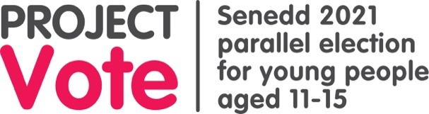****

**Project vote: Lesson one**

This worksheet should be done while following the powerpoint presentation.

**Question**:

Do elections affect you?

|  |
| --- |
|  |

**My daily timetable**

Follow the example on the screen and include as much detail as possible. When you have completed your daily timetable highlight the things that you think are affected by the Senedd.

|  |
| --- |
|  |

I didn’t know that the Senedd affected: _________________________________________________________________________________________________________________________________________________________________________________________________________________________________

**Senedd or Westminster**

**Tick which one you think it is.**

|  |  |  |
| --- | --- | --- |
|  | **Senedd** | **Westminster** |
| **Question 1:** Which parliament’s building collects rainwater to flush toilets and burns recycled material for heating? |  |  |
| **Question 2:** Which parliament's members decide who can get free school meals in Wales? |  |  |
| **Question 3:** Which parliament's members decide the Coronavirus restrictions in Wales? |  |  |
| **Question 4:** Which parliament's members affect how hospitals are run in Wales, and how you get help with your mental health? |  |  |
| **Question 5:** Which parliament did Guy Fawkes try to blow up on November 5th 1605? |  |  |
| **Question 6:** Which parliament's members decide if children in Wales should sit GCSE and A-Level exams? |  |  |
| **Question 7**: Which parliament’s members were the first to introduce the 5p plastic bag charge? |  |  |
| **Question 8:** Which parliament's members decide where members of the armed forces in Wales go and what they do? |  |  |
| **Question 9:** Which parliament's members affect how much money your council has to spend on youth clubs? |  |  |
| **Question 10:** Which parliament's members decide the cost Welsh students pay when they go to university? |  |  |
| **Question 11:** Which parliament's membes can make rules for social media companies to keep young people safe online? |  |  |
| **Question 12:** There are 100 staircases, more than 1,000 rooms and three miles of corridors in this parliament. Which one? |  |  |