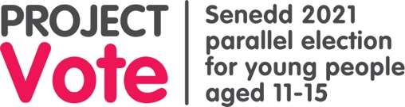
Lesson Two: Project Vote Home learning

Question: Watch the video about the Senedd, write down three things you have learnt.
1.
2.
3.

What do members of the Senedd do?

Highlight the four correct statements.

Walk dogs from the local dog shelter every week | Vote for new laws in Westminster | Answer questions on BBC news every week
Attend a monthly ceremony in the Senedd, where a three-course meal is served, followed by a dance | Keep challenging the Welsh Government to make things better for people in Wales | Vote for new laws in the Senedd and take part in debates
Listen to their local community members and raise their issues in the Senedd | Some are asked to be part of the Welsh Government. They help decide how to run the country and how money is spent. | Raise money for charities by taking part in the weekly Senedd cross-country run

Is there anything about how the Senedd that you found difficult to understand?
(If it's possible, your teacher might like to run the 'Mini Senedd' activity, which is on our resources page under face-to-face lesson plans.)

My kahoot score was: ___________________________________

Extra activity
Take a look at the map, hide the writing on either side. Can you pinpoint your region and constituency?
Remember constituencies are the smaller areas and regions are the larger ones.
Uncover the writing and see if you are correct.
I live in _________________________.
My local constituency is_________________. My region is ____________________.

