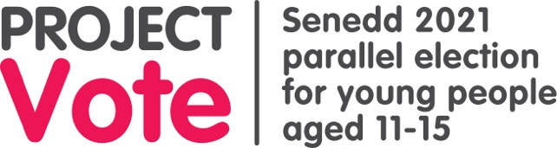

Objects of reference
Reference | Object
Senedd | Reference picture
Election/vote | Ballot Paper
Politician/MS | Rosette
Law | Judge wig/gavel
Wales | Map
Constituencies | Constituency map with your constituency highlighted
Regions | Region map with your region highlighted

