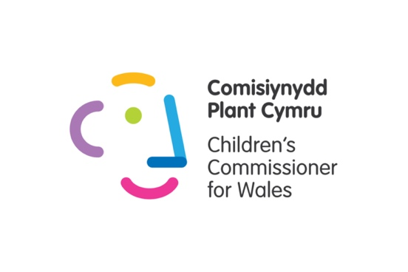
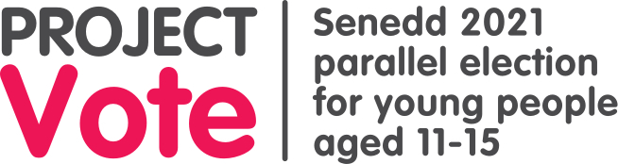
Project Vote Activities
The activities from our Project Vote lesson plans are below, with some approximate timings. You can use these activities to adapt and build a lesson tailored to your group.

Daily timeline (15 mins)
Young people can link elements of their own lives to elections  Young people know that Wales makes its own laws in some areas, and this is separate to the rest of the UK | Ask young people whether they feel that elections affect them. You could do a hands up/hands down vote or a group discussion.  Tell them that the next activity will help them think about their day-to-day lives and the issues they care about.  Option 1: Daily timeline  Ask young people to write a timeline of their typical day.  Ask them to include as many details as possible e.g. how they travel, where they go, what they do there, who they meet.  You could ask them to think about what they do roughly for each hour of the day, as a guide.  The purpose of the activity is for young people to consider how they’re affected by decisions made by the Senedd.  (10 mins)  OR  Option 2: Group discussion  You could introduce a topic to the group, one which is likely to have differing viewpoints, and have an open discussion. There are some examples below:  - Education should be compulsory until age 18  - Public transport should be free for everyone  - A new town or city should be built on your local green space (you could use an example in your community e.g. the Gower, Dyfi Forest)  - All sports clubs in Wales should be closed in order to save money  (10 mins)  Next  After young people have done one of these activities, go to the next slide (Powerpoint 1). It gives examples of some of the areas that the Senedd has control over.  It includes examples that may have been discussed in the last exercise.  Ask young people to think back on the last activity and consider whether they feel elections have an impact on their day-to-day lives and the things they care about. You could ask them to raise their hands again to demonstrate their answer and see whether their opinion has changed. (5 mins) | Young people may have queries about what the UK Parliament in Westminster controls. Some examples are immigration, Brexit, armed forces, and social security (benefits).

Senedd or Westminster? (25 mins)
Young people can link elements of their own lives to elections  Young people know that Wales makes its own laws in some areas, and this is separate to the rest of the UK | Explain to the young people that some of the laws which affect people in Wales are made by politicians in Cardiff Bay in the Senedd, or the Welsh Parliament (both terms mean the same thing). Some laws are made by politicians in London in Westminster also affect us in Wales, as well as the rest of the UK.  Tell the young people you will play a game called ‘Senedd or Westminster’. You’ll have facts on the powerpoint slide (Powerpoint 1) that relate to each - they will have to say whether they think the facts are about the Senedd or Westminster.  Ask the questions noted on each slide. The answers are in the slide notes.  - Which parliament’s building collects rainwater to flush toilets and burns recycled material for heating? (Senedd)  - Which parliament's members decide who can get free school meals in Wales? (Senedd)  - Which parliament's members decide the Coronavirus restrictions in Wales? (Senedd)  - Which parliament's members affect how hospitals are run in Wales, and how you get help with your mental health? (Senedd)  - Which parliament did Guy Fawkes try to blow up on November 5th 1605? (Westminster)  - Which parliament's members decide if children in Wales should sit GCSE and A-level exams, and are responsible for any rules that both schools and independent candidates have to follow? (Senedd)  - Which parliament’s members were the first to introduce the 5p plastic bag charge? (Senedd)  - Which parliament's members decide where members of the armed forces in Wales go and what they do? (Westminster)  - Which parliament's members affect how much money your council has to spend on youth clubs? (Senedd)  - Which parliament's members decide the cost Welsh Young people pay when they go to university? (Senedd)  - Which parliament's membes can make rules for social media companies to keep young people safe online? (Westminster)  - There are 100 staircases, more than 1,000 rooms and three miles of corridors in this parliament. Which one? (Westminster)  (10 mins)  Now that the young people know that different decisions are made by politicians in different parliaments, how does that make them feel?  Do they know what decisions are made by their local councils (e.g. Rhondda Cynon Taf CBC or Conwy CBC)? These could be:  - When bins should be collected  - Repairing roads  - How your local park is looked after  - Keeping local paths tidy  (15 mins) | You could facilitate this activity as a quiz, where the young people write down their answers and you go through them at the end. Otherwise, you could ask the young people to show their answer for each question and reveal the answer as you go along, for example  - Hold up a whiteboard or piece of paper with Senedd/Westminster written on it  - ‘Show’ their answer e.g. hands on their head for Senedd and hands in the air for Westminster.  .
What does a Member of the Senedd do? (10 mins / 20 mins with extension)
Young people understand what a member of the Senedd does, and why they would contact their MS | Tell the young people you are going to learn more about what a Member of the Senedd does.  Option 1  Use the ‘What do Members of the Senedd do?’ slide (powerpoint 2). It has 9 statements about what Senedd members do - 5 are wrong and 4 are right.  Ask young people to work in pairs to find the four correct answers.  The next slide reveals the four right answers.  OR  Option 2  Use the ‘What do Members of the Senedd do?’ handout to do this activity. It has the same options as the slide. It can be completed individually or in pairs.  - The correct answers are:  - Challenge the Welsh Government to make things better for people in Wales  - Vote for new laws in the Senedd and take part in debates  - Listen to their local community members and raise their issues in the Senedd  - Some are asked to be part of the Welsh Government. They help decide how to run the country and how money is spent.  (10 mins) | Extension Activity:  Give young people some scenarios and ask them to consider whether it’s something they could contact their MS about. Examples:  - You regularly use the bus to go to your youth club in the city centre. You've heard that your local bus station is being closed and no buses will stop there. - YES  - The local nature reserve has been polluted by a nearby factory and is being destroyed. - YES  - You went to GAME to buy the latest FIFA game but they haven't had any in stock for 2 weeks - NO (Members of the Senedd have no control over shop stock!)  - You want to have your say about plans for the UK to send troops to a foreign country. NO - One for your MP (Member of Parliament – UK)  It's worth telling young people not to worry too much about contacting the right person. Your MS should help you contact the right person if that person is not them.  Remind young people they have 5 MSs they could contact (1 in their constituency and 4 in their region).

Mini Senedd Activity (20 mins)
Understand how seats in the Senedd translate to power | Tell the group that to show them how the Senedd works you will pretend that your room is the Senedd, and they are all politicians.  Write three parties down on the whiteboard - Party A, Party B, and Party C, along with some of the things they want. These are called policies.  ___________________________  Party A  Party A wants school to start at 10am and finish at 4pm.  Party A wants every group to have a pet dog.  Party A wants to ban buses and cars so all young people walk or cycle to school, even if you live miles away. They’ll give every student a new bike and build new bike sheds.  Party B  Party B wants school to start at 8am and finish at 2pm.  Party B wants every group to have a pet cat.  Party B wants every school bus to have wi-fi and charging points.  Party C  Party C wants school to stick to the current start and finish times.  Party C doesn’t want any pets in group.  Party C wants everyone to get to school as they normally do.  __________________________  Ask the young people which party they would want to be a part of if they were a Member of the Senedd.  Ask them to put their hands up if they would want to be in Party A, then Party B, then Party C.  Count how many of them are a part of each party. Write their names under each Party on the whiteboard then count the amount of ‘seats’ (members) each party has.  Count the amount of seats in the group - how many would one party need to have a majority?  If there is one party with a majority, this party can go ahead and make a Government and try to make their policies come true.  They do this by holding votes on any new policies they want to make. For instance, let’s pretend Party A had a majority. Because they want school to start at 10am and finish at 4pm, they need to let all the other Senedd members vote to see if they want it too. But because they have a majority, they can all vote for it and there wouldn’t be enough other Senedd members to stop them. | This activity should demonstrate that the more members from the same party in the Senedd, the easier it is to pass laws.  If there isn’t a party with a majority, the biggest party would need to work with one of the smaller parties to make sure their policies are voted for.  For instance, if Party A have the biggest party, but have less than half the seats, they could agree with a smaller party that they will help them with one of their policies, if they help them with school timings in return.  So Party A could agree to vote for no pets in group, if Party C agrees to vote for school to start at 10am.  To follow what would happen in Plenary, you could give the opposition (minority) parties the opportunity to put forward an amendment (a different suggestion). This could then get voted on too.

Project Vote Kahoot Quiz (10 mins)
Reinforce learning | Play this video: https://www.youtube.com/watch?v=WoSG115QpCY  Re-cap the lesson by taking part in the Kahoot! Quiz. All the answers to the questions were covered in the video.  https://create.kahoot.it/share/quiz-2021-senedd-elections/2c90f476-0971-4b89-bc17-153ef2dfd353  Questions and answers:  - How many members of the Senedd are there? (60)  - There are 40 of these smaller areas in Wales, what are they called? (Constituencies)  - There are 5 of these bigger areas in Wales, what are they called? (Regions)  - How many votes will you have when you take part in Project Vote? (2 - constituency and region)  - How many Members of the Senedd represent you? (5)  - What does the party who gets the most Senedd members normally do? (Form a Government)  - Who chairs (takes charge of) meetings in the Senedd? (Presiding Officer)  - Who do Members of the Senedd choose to lead the Welsh Government? (First Minister)  - Which one of these things does a Member of the Senedd do? (tri ateb cywir) Vote for new laws in the Senedd, Challenge the Government to make things better for people in Wales, Listen to their local community members and raise their issues in the Senedd  (10 mins) | Young people can use notes from the activities to help them.  You could still do the quiz as a pub quiz style, if you can’t access Kahoot!  For an extra challenge, ask them to do the quiz without looking at their notes.

