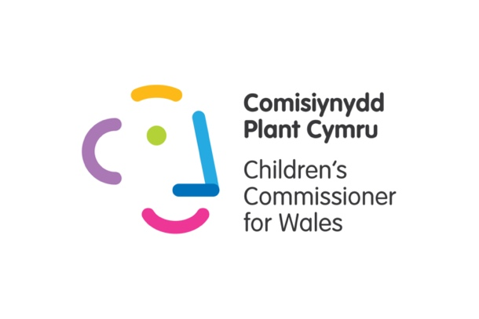
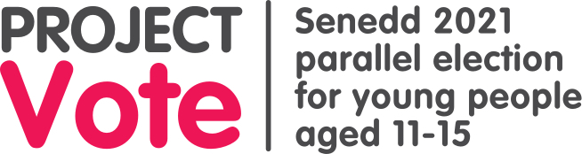

Dear Teacher,

This lesson plan might help your pupils to learn more about each party's policies, and to decide who to vote for in the parallel election.

As an apolitical organisation, we are unable to provide you with any information on behalf of political parties, e.g. simplified manifestos or videos.

Instead, we have urged political parties in Wales to make materials this year that are suitable for young people, including young people taking part in our parallel election.

When these are published, you'll find these on parties' websites. Please note that some manifestos have been delayed because of the death of the Duke of Edinburgh.

But as we've noted in the lesson plan, there are many ways pupils can find out more about political parties' views, as well as looking at their manifestos, including videos, social media accounts, and leaflets.

We've included some detailed options in the lesson plan.

It goes without saying that in delivering this lesson, it is important to remain politically neutral throughout, without disclosing your own party preferences if asked by pupils.

If you have any questions or need help with anything please let us know - projectvote@childcomwales.org.uk

Lesson 3

Lesson objectives:

- Pupils consider their top priorities for the election
- Pupils learn about each party’s aims through reading manifestos
- Pupils feel more prepared to vote in Project Vote

Note to teachers: the timings in this lesson plan are a guide. You may wish to allow pupils more or less time on each activity depending on the needs of the group

Key questions:
What is a vote?
How do we decide who to vote for?

Some learners will: Be able to use political material to inform their vote
Most learners will: Know that political parties publish manifestos ahead of an election
All learners will: Know that an election is taking place in 2021

Learning outcome | Activity | Additional information
Reflect on the last lesson | Circle time: Manifesto  Remind pupils that you have been learning about elections and political parties.  Explain that during an election, political parties create a manifesto. A manifesto is a list of all the things they promise to do if they win the election. This will happen before the Senedd elections.  Why do you think political parties make manifestos (a list of promises)?  Revisit learning from the Senedd. Ask pupils if they can remember any of the things the Senedd makes decisions about? You can use our symbols to support thinking. | This part of the lesson will only be relevant to those who have completed Lessons 1 & 2.  If starting with this lesson, you could adapt the questions to find out how much pupils know about the Senedd.
Pupils consider their top priorities for the election | Tell pupils that in this lesson you are going to think about the things that are important to them and how this can help them decide who to vote for.  Activity Options:  Option 1:  Ask pupils to make a ‘Diamond 9’ of issues the Senedd has power over. They can use their own ideas or use the symbols in Appendix 1.  Option 2:  Ask pupils to think about the top three things they would do, if they were in charge of Wales. You could use the images in appendix 1 to help.  Option 3:  Ask pupils to search for or draw three pictures which represent the things that are important to them. You could use the images in appendix 1 to help.
Pupils learn about each party’s aims through reading manifestos | Remind pupils that before an election, political parties make a list of all the things they say the party will do, if they win the election – a document which is usually called ‘a manifesto’.  Tell pupils that they will look at materials from different parties, which have been published for the Senedd 2021 election.  They will compare their top priorities from the last activities with what the parties say they will do in their manifestos.
Pupils feel more prepared to vote in Project Vote | You could choose the most appropriate materials for your pupils,  These could include:  - Manifestos published on party websites  - Party political broadcasts on iPlayer  - Youtube videos  - Videos on party websites  Remember to include materials from every party standing in your local area.  You could also contact the party to drop off leaflets with their manifesto’s key points to your school or setting, which might be a more accessible option for pupils.  Pupils can look at as many or as few as they want.  Allow pupils time to look through the materials and find out if any of the parties share their priorities. You could Provide pupils with key words to go alongside their priorities; this will help them to match their priorities with the manifestos.  Ask the following questions:  - If you look at your top three priorities, do they match any of the manifestos?  - Can you share something the party thinks is important?  We've included some specific alternative options to using manifestos here:  Option A  We asked the political parties standing in every constituency to tell us what they will do for young people if they win the election.  Those parties are: Conservatives; Labour; Liberal Democrats; Plaid Cymru; Reform UK.  We received responses from Labour, Liberal Democrats, and Plaid Cymru.  We've put their responses into this document.  For the other parties/candidates standing in your area, you could use the BBC's policy comparison tool, or use our spreadsheet to get the email addresses of your local candidates.  Option B  Use a comparison tool to see summaries of parties’ views in different areas:  https://www.bbc.co.uk/news/uk-wales-politics-56499726  Option C  Use our spreadsheet to see who is standing in your area.  Email the candidates explaining that your pupils are taking part in a Parallel Senedd election organised by the Children’s Commissioner, and that your pupils would like to know the top 3 aims they or their party have for young people. What will they do if they are elected? Make sure you give them a deadline for responses.  If you need any help or advice with this please contact us.  We've made this template email for you:  Dear INSERT NAME OF CONSTITUENCY Candidates  I am a Teacher at INSERT SCHOOL.  My pupils are taking part in a parallel election for young people organised by the Children's Commissioner for Wales.  On INSERT DATE pupils will be learning more about what each candidate/party has to offer.  Can you please send me three simple bullet points saying what you or your party will do if you win the seat/the election?  Please can you send these to me by INSERT DATE?  How will you know who's standing in your constituency and region?  We've made this spreadsheet showing you this information.  Where possible this spreadsheet contains details of candidates' social media profiles and websites, so that pupils can use these too if they want.  Remember that for the parallel election, we use the school's postcode to determine the constituency/region your pupils will vote in.  How do I know which constituency and region the school is in?  If you're not sure which constituency your school is in, take a look at this spreadsheet.  Option D  Wales Online are holding a Youth Hustings at 8pm on Wednesday 14 April, giving young people the chance to ask politicians about the things that are important to them.  It will be broadcast on Wales Online’s Youtube and Facebook pages and will be available to view afterwards.  Watching this could be another useful classroom resource for your pupils to help them decide who to vote for. | How will you know who's standing in your constituency and region?  After 9 April, the final list of candidates and their parties who are standing in your area will be published on your local authority's website.  But to make things easier for you we've made this spreadsheet showing you the latest information. Please be aware that if you look at this before April 9, some candidates might still be added before the list is made final.  Where possible this spreadsheet contains details of candidates' social media profiles and websites, so that pupils can use these too if they want.  How do I know which constituency and region the school is in?  If you're not sure which constituency your school is in, take a look at this spreadsheet.
Close | Finish the lesson by reminding pupils that they will have the opportunity to vote on XXX date as the school is taking part in Project Vote.  Remind pupils that they don't need to tell anybody else who they are voting for.  They have a right to have their say, and a right to privacy. | Extension activity:  You could invite pupils to create posters for their school/building advertising the parallel election in your school. The posters could contain voting rules (e.g. secret ballot, cross in the box).

Appendix 1:

