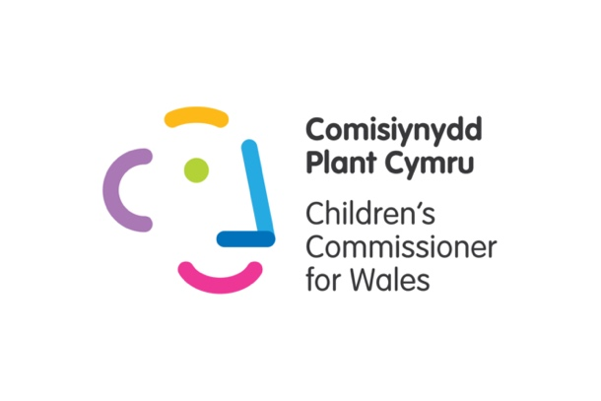
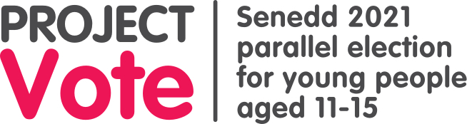

Dear Teacher,

This lesson plan might help your pupils to learn more about each party's policies, and to decide who to vote for in the parallel election.

As an apolitical organisation, we are unable to provide you with any information on behalf of political parties, e.g. simplified manifestos or videos.

Instead, we have urged political parties in Wales to make materials this year that are suitable for young people, including young people taking part in our parallel election.

When these are published, you'll find these on parties' websites. Please note that some manifestos have been delayed because of the death of the Duke of Edinburgh.

But as we've noted in the lesson plan, there are many ways pupils can find out more about political parties' views, as well as looking at their manifestos, including videos, social media accounts, and leaflets.

We've included some detailed options in the lesson plan.

It goes without saying that in delivering this lesson, it is important to remain politically neutral throughout, without disclosing your own party preferences if asked by pupils.

If you have any questions or need help with anything please let us know - projectvote@childcomwales.org.uk
Lesson 3

Lesson objectives:

- Pupils consider their top priorities for the election
- Pupils learn about each party’s aims through reading manifestos
- Pupils feel more prepared to vote in Project Vote

Note to teachers: the timings in this lesson plan are a guide. You may wish to allow pupils more or less time on each activity depending on the needs of the group

Learning outcome | Activity | Additional information
Reflect on the last lesson | Remind pupils that Wales has its own parliament that makes laws only for Wales. It’s called the Senedd, or Welsh Parliament - both terms mean the same thing. There are certain areas where the Senedd can’t make laws - the UK Parliament in Westminster is responsible for making laws in these areas.  Re-cap learning from the last lesson by asking the following questions:  - How many members of the Senedd are there? (60)  - There are 40 of these smaller areas in Wales, what are they called? (Constituencies)  - There are 5 of these bigger areas in Wales, what are they called? (Regions)  Use this map if you want a reminder.  Remind pupils that most Members of the Senedd (MS) belong to a party. Some stand as ‘independents’.  Remind pupils that when they vote, they will have one vote for their constituency (one MS will be elected) and one vote for their region (four MSs will be elected overall for the region).  (5 mins) | This part of the lesson will only be relevant to those who have completed Lessons 1 & 2.  If starting with this lesson, you could adapt the questions to find out how much pupils know about the Senedd.
Pupils consider their top priorities for the election | Tell pupils that in this lesson you are going to think about the things that are important to them and how this can help them decide who to vote for.  Activity Options:  Option 1:  Ask pupils to make a ‘Diamond 9’ of issues the Senedd has power over. They can use their own ideas or use the symbols in Appendix 1. Tell pupils to use their top three for the scoring matrix in the next activity.  Option 2:  Ask pupils to think about the top three things they would do, if they were in charge of Wales. Tell pupils to use their ideas for the scoring matrix in the next activity.  Option 3:  Ask pupils to search for or draw three pictures which represent their top priorities. Tell pupils to use these for their scoring matrix in the next activity.  (15 mins)
Pupils learn about each party’s aims through reading manifestos | Explain that before an election, political parties publish a manifesto. A manifesto is a list of all the things the party says they will do, if they win the election. Independent candidates might publish their own manifesto.  Tell pupils that they will look at manifestos from different parties, which have been published for the Senedd 2021 election.  They will compare their top priorities with the party manifestos.
Pupils feel more prepared to vote in Project Vote | There are a few options here – you could pick whatever best suits your pupils.  Option A  We asked the political parties standing in every constituency to tell us what they will do for young people if they win the election.  Those parties are: Conservatives; Labour; Liberal Democrats; Plaid Cymru; Reform UK.  We received responses from Labour, Liberal Democrats, and Plaid Cymru.  We've put their responses into this document.  For the other parties/candidates standing in your area, you could use the BBC's policy comparison tool, or use our spreadsheet to get the email addresses of your local candidates.  Option B  Use a comparison tool to see summaries of parties’ views in different areas:  https://www.bbc.co.uk/news/uk-wales-politics-56499726  Option C  Use our spreadsheet to see who is standing in your area.  Email the candidates explaining that your pupils are taking part in a Parallel Senedd election organised by the Children’s Commissioner, and that your pupils would like to know the top 3 aims they or their party have for young people. What will they do if they are elected? Make sure you give them a deadline for responses.  If you need any help or advice with this please contact us.  We've made this template email for you:  Dear INSERT NAME OF CONSTITUENCY Candidates  I am a Teacher at INSERT SCHOOL.  My pupils are taking part in a parallel election for young people organised by the Children's Commissioner for Wales.  On INSERT DATE pupils will be learning more about what each candidate/party has to offer.  Can you please send me three simple bullet points saying what you or your party will do if you win the seat/the election?  Please can you send these to me by INSERT DATE?  How will you know who's standing in your constituency and region?  We've made this spreadsheet showing you this information.  Where possible this spreadsheet contains details of candidates' social media profiles and websites, so that pupils can use these too if they want.  Remember that for the parallel election, we use the school's postcode to determine the constituency/region your pupils will vote in.  How do I know which constituency and region the school is in?  If you're not sure which constituency your school is in, take a look at this spreadsheet.  Option D  Wales Online are holding a Youth Hustings at 8pm on Wednesday 14 April, giving young people the chance to ask politicians about the things that are important to them.  It will be broadcast on Wales Online’s Youtube and Facebook pages and will be available to view afterwards.  Watching this could be another useful classroom resource for your pupils to help them decide who to vote for.  Option E  Ask pupils to choose party manifestos and complete the scoring matrix (template in Appendix 2).  Pupils will be able to find a party's manifesto by visiting the party's main website.  A tab on this spreadsheet shows party websites.  Pupils can look at as many or as few of the manifestos as they want.  Pupils could try searching for information from other sources too to help them decide, such as news stories, YouTube videos and social media posts.  Party political broadcasts are usually kept on BBC iPlayer - these could also be good to use in the classroom as an alternative to manifestos.  They could also bring in any political leaflets that have been posted to them.  When finished, ask the following questions:  - Did anybody have a party with a clear high score?  - What stands out to you about the manifestos?  - Which party’s manifesto did you like the most and why?  - Do you think the parties made content that was suitable for young people? We would be interested in hearing this feedback if pupils would like to share it with us.  - Can you share something the party thinks is important?  (25 mins) | Extension activities:  1. Ask pupils to read the party manifestos. What sort of language is used in the manifestos? How is the information presented? How do they persuade people to vote for them? Has the party written any information that is suitable for young people?  2. Ask pupils to consider the reliability of different sources of information when it comes to elections. You could share this short lesson/presentation on fake news (misinformation and disinformation) with them.  3. Ask pupils to write an email to your local candidates and ask them what they or their party will be doing to help young people in Wales/to help your area/to improve a particular issue they care about?
Close | Finish the lesson by reminding pupils that they will have the opportunity to vote on XXX date (any time between April 19-30) as the school is taking part in Project Vote.  Remind pupils that they do not need to tell anybody else how they intend to vote in the parallel election.  They have a right to have their say, and a right to privacy.  (5 mins) | Extension activity:  You could invite pupils to create posters for their school/building ready to advertise the parallel election in your school. The posters could contain voting rules (e.g. secret ballot, cross in the box).

Appendix 1:

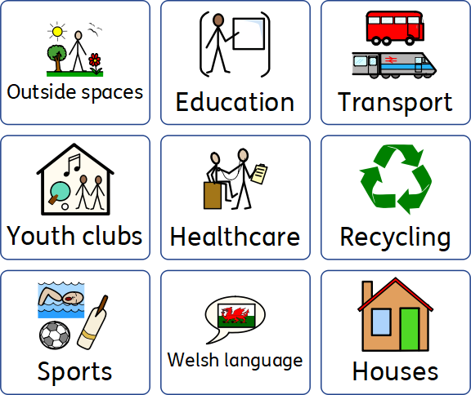

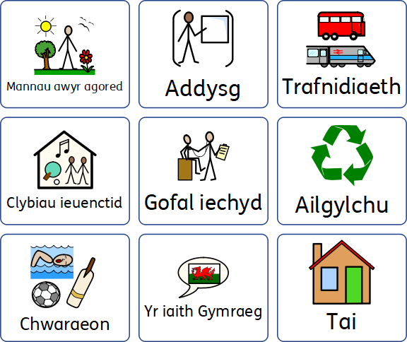

Appendix 2: Scoring Matrix Template
Write about or insert a picture of your top 3 priorities in the first column. In each box, write what each party says about each priority. Give each party a score (out of 10) based on how well you like their ideas. Add up the scores at the bottom.

 | Party name: | Party name: | Party name:
Priority 1: | Score: | Score: | Score:
Priority 2: | Score: | Score: | Score:
Priority 3: | Score: | Score: | Score:
 | Total score: | Total score: | Total score:
We’ve started you with three columns but you can add as many as you like.

