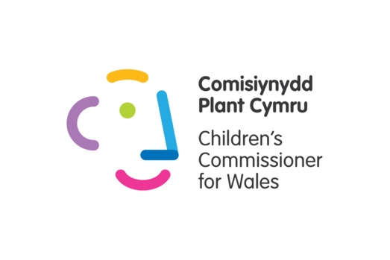
Project Vote – Lessons for KS2
Lesson One: The Council
Activity | Extension/ Scaffolding
Introduction:  Today we are going to learn about the council.  We will talk about which council our school is in.  We will learn about what a council does.  Share the logo for your local council with pupils (we recommend using the logo of the council your school is in as a focus for this session).  Ask:  Has anyone ever seen this logo before?  Where have you seen it?  Explain:  This is the logo for our local council.  Does anyone know the name of the council the school is in?  Work together to find the council on a map of Wales. You could use a paper map or ask pupils to use maps on the computer.  Ask pupils: “Who knows what councils do?”  - Take answers and place them on the board if pupils think they know (return to those answers at the end of the next section)  - If pupils say they don’t know explain that you will be learning about councils in this lesson. | Some learners in your class might live in different councils. You may want to explain that they would have a different logo and share their logo with them where possible.
Main:  Explain to pupils:  The council makes decisions about some things in our community.  Tell students you are going to find out what things your local council has control over in the next activity.  Use this picture as the focus of the activity.  We've written the answers and some explainers in this document.  Give pupils time to look at the image and talk about what they can see.  Give each pupil an “I spy….” sheet from the resource pack (page 1).  Pupils could:  - Use the symbols cards on page 2 and 3 of the resource pack - this could be used for small group work. We would recommend handing the pupils a symbol once they have spotted the corresponding drawing in the picture.  - Write or draw the things they can see.  You could prompt pupils to talk about the picture by using the following questions:  “Can you see anything exciting?”  “What do you think is happening here (point to specific part of the picture)”  “What is next to the XXX?”  Next, explain to pupils:  “Now we have a list of different things on our “I Spy…” sheet we are going to find out if the Council controls it.  Use the answer picture (with circles highlighting the things the council controls). Ask pupils to put a tick next to the items on their “I Spy” sheet.  Explain that the council controls all of the items circled on the picture:  - Taxis  - Adoption and fostering (on the billboard of the community centre)  - Litter/ Rubbish  - Street lights  - Recycling (bags in front of the shops)  - Road repairs  - Libraries  - School (note: the council funds local schools but doesn’t make decisions on the curriculum)  - Park  - Public toilets  - Building houses  - Shop  - Statue  - Cycle path  - School bus  - Community Centre  - Dog mess (Dog mess bins and fines)  - Beaches (Some beaches will be the responsibility of the council, but others will be run by private companies) | We recommend printing the picture on A3 for group work or using the screen at the front of the class and running it as a whole class lesson.  Extension discussion: What would you spend money on if you were the council?  You could use the symbols on the Council Handout to do a diamond ranking activity. Ask pupils to rank the different cards in order of importance and hold a discussion.  If you are doing this with pupils who are visually impaired you might want to turn it into a description activity, you can describe the thing you can see and they guess what it is.  For example:  “A big vehicle that helps take injured people to the hospital”.
Close:

Recap the session with the following questions:
Show council logo –
“Who can remember what this is?”
“What does a council control?”

Explain to pupils:

This year everyone over the age of 16 in Wales, will have the chance to vote for people in a council election.

We will take part in a pretend vote in school.

We will learn more about voting in our next session.

Lesson 2: Voting
This lesson is a circle time discussion.
Activity | Extension/ additional activities
Start the discussion with a recap of the last session.  Show the class the council’s logo and ask if they remember what the picture is?  Ask if pupils can remember one thing a Council has control over. You might want to use the Council handout from the last lesson to aid discussions.  Next explain:  There are lots of times in our life when we vote. Who can think of something we vote for?  Start by sharing a picture of a school council and asking if pupils have voted for their school council / class rep before. Remind pupils how the vote works in your class/ school.  Next show a picture of a popular voting show like Strictly Come Dancing or I’m a celebrity. Ask pupils if they have ever voted for someone in a show before.  Explain that people use phones to choose the person they think should win the show.  Finish by showing a picture of Mark Drakeford and Boris Johnson. Ask pupils if they know who they are.  Explain that Mark Drakeford is the First Minister for Wales and Boris Johnson is the Prime Minister for the United Kingdom.  When we vote for people like Mark Drakeford or Boris Johnson it’s called an election.  Elections are where we vote for people who make decisions about things in our lives.  In Wales people vote in different elections.  Practice Vote  Explain to pupils:  Today we are going to practice voting as a class.  Choose two activities pupils enjoy doing in class and explain that they can only choose one. The activity with the most votes will win and pupils will enjoy it as a group later in the day.  Use a vote that best suits your pupils. This could be hands up, dot voting, moving to the picture of their preferred activity.  Finish the activity by explaining:  This year people are voting for their local council.  This year people over 16 years old can vote in the election.  We will take part in a pretend election in school.  Next session we will learn a bit more about the people we can vote for, and then we will take part in a vote on the computer/ ipad. | You might want to look at a map of the United Kingdom to show pupils where Wales is and highlight where the First Minister is based. You could then highlight where the Prime Minister is based.  You could also show pupils a picture of the Senedd/ Westminster to explain where they work.

