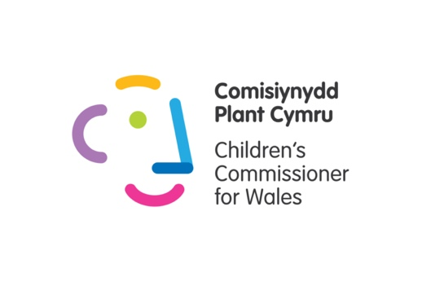
We've written this guidance to give you relevant background information on some of the activities in each lesson.

We know that some of the issues are complex, so we've tried to explain in them in more detail.

If you'd like any more information or help please get in touch with us - projectvote@childcomwales.org.uk

Lesson Plan 1

Students understand the different types of elections that happen in Wales

Here are some more of the responsibilities of the council, the Senedd/Welsh Parliament, and the UK Parliament.

In the lesson plan summary table, we've stuck to a small number of specfic areas.

We hope this longer list will help you to answer any further questions from pupils.

The local council

Local councils deliver services in these areas:

- Providing education, including deciding how much of their budget to spend on education, making sure there are enough local schools to meet demand, and making sure school transport is available for children
- Housing, for example finding accommodation for people in need, and maintaining social housing
- Social services, for example caring for and protecting children, older people and disabled people
- Highways and Transport, including maintaining roads and managing traffic flow
- Waste Management, including collecting rubbish and recycling
- Leisure and Cultural Services, for example providing libraries, leisure services and arts venues.
- Consumer Protection, such as enforcing trading standards and licencing taxis
- Environmental Health and Services, for example making sure that the food provided in pubs and restaurants is safe to eat, and controlling pollution locally
- Planning, including managing local developments and making sure buildings are safe
- Economic Development, for example attracting new businesses and encouraging tourism
- Emergency Planning, for things like floods or terrorist attacks

Senedd/Welsh Parliament (these terms are interchangeable)

Here are some areas where the Senedd has powers:

- The Environment
- Housing
- The NHS in Wales
- Healthcare
- Fire and Rescue Services
- Sport and Leisure
- Food Ancient Monuments
- Tourism
- Education
- Agriculture
- The Welsh Language

The Senedd passes laws that cover the whole of Wales.

Why are some of these responsibilities the same as the council's?

Everybody in Wales , including the local council, who provides services in these policy areas has to follow laws passed by the Senedd.

So the Senedd sets the rules, and the council then has to provide the service within these rules.

For instance, councils have to give school transport to everyone in secondary school who lives more than 3 miles away from the nearest suitable school, because there is a Senedd law that says they have to.

UK Parliament

Some of the things under UK Parliament control:

- The Internet in the UK (including rules social media companies have to follow - new laws are being drafted on this at the moment)
- Benefits
- Immigration
- Crime and Policing
- Hunting
- Foreign affairs, including controlling the armed forces

Lesson Plan 2

Picture activity

The parts of our illustration that the council are responsible for are:

- Streetlights

- Bin/recycling collection

- Repairs to roads

- The library

- The school - giving schools money to run, providing school transport, making sure there are enough schools to meet demand, making sure children with additional learning needs have the right support.

- The park

- Public toilets

- New housing development - Companies who want to build a new housing estate for instance need to have the council's permission to do it

- Local businesses - Making sure that businesses are operating legally and fairly by enforcing Trading Standards

- Statues

- Cycle paths

- School bus - providing school transport

- Community Centre

- Beach - Councils will be responsible for maintaining some beaches in their local areas, although some will be maintained by private companies. If you're unsure and you want to know, use the website Write to them to write to your local councillor

- Dog poo - Councils will be responsible for making sure there are enough bins for dog poo, and introducing and enforcing fines for not cleaning up after your dog.

- Litter - Same as dog poo

- Taxis - Giving taxis licences to operate, to make sure that they are safe and comfortable and that the drivers are suitable.

- Billboard asking for people to adopt/foster - the council will be responsible for protecting vulnerable children by taking them into care, and then finding a suitable family for them to live with through fostering or adoption

Lesson Plan 3

Students understand some of councillors’ day-to-day duties activity

Relevant to the answer 'Be honest, open, and respectful' - there is a code of conduct that all councillors must follow, which includes being honest, open, and respectful when carrying out their duties.

